"IT WORKSHOP USING PYTHON LAB”

A LAB RECORD SUBMITTED IN PARTIAL FULFILLMENT

OF THE REQUIREMENTS FOR THE SUBJECT “IT WORKSHOP USING PYTHON” OF

**Bachelor of Technology (Computer Science)**

**Submitted by:**

HIBBANUR RAHMAN

B.Tech. (Computer Science) 2nd Year

Roll Number: 21BTCS026HY

Enrollment Number: A210044

**Submitted to:**

MOHAMMAD ISLAM

Assistant Professor

Department of Computer Science & Information Technology

Maulana Azad National Urdu University, Hyderabad



DEPARTMENT OF COMPUTER SCIENCE & INFORMATION TECHNOLOGY SCHOOL OF TECHNOLOGY

MAULANA AZAD NATIONAL URDU UNIVERSITY

Gachibowli, Hyderabad, Telangana-500032 (India)

**MAULANA AZAD NATIONAL URDU UNIVERSITY**

**Gachibowli, Hyderabad, Telangana-500032 (India)**

**(Accredited with “A+” Grade by NAAC**



Certificate

This is to certify that the lab record file by **HIBBANUR RAHMAN** bearing Enrollment Number **A210044** submitted in partial fulfillment of the requirements for the subject **“IT Workshop using Python”** with course code **“BTCS362PCP”** in **Bachelor of Technology** (Computer Science) **3rd Semester**

during 2022-23 at the **Department of Computer Science & Information Technology** is a bonafide laboratory work carried out by him under mysupervision.

The results presented in this file have been verified and are found to be satisfactory.

**Signature of Internal Examiner Signature of External Examiner**

|  |  |  |
| --- | --- | --- |
| S.No. | NAME OF EXPERIMENT | PAGE NUMBER |
| 1 | Write a Program to demonstrate a string | 11 |
| 2 | Write a Program to demonstrate a Tuple | 12 |
| 3 | Write a program to demonstrate a list | 13-14 |
| 4 | Write a program to demonstarte a dictionary | 14 |
| 5 | Write a program to demonstrate arithmetic operations | 15 |
| 6 | Write a program to dmonstarte comparision operator | 16 |
| 7 | Write a program to demonstrate assighnmnet operator | 17 |
| 8 | Write a program to demonstarte bitwise operator | 18 |
| 9 | Use REPL and print the table 5 using it. | 19 |
| 10 | Write a python program to find average of two numbers | 20 |
| 11 | Q.11 Write a python program to find greatest of four numbers entered by the user? | 21 |

|  |  |  |
| --- | --- | --- |
| S.No. | NAME OF EXPERIMENT | PAGE NUMBER |
| 12 | Write a python program to calculate the square of two numbers entered by the user? | 22 |
| 13 | Write a python program to fill in a letter template with a name and date**?** | 22 |
| 14 | Write a python program to detect double space in a string? | 22 |
| 15 | Write a python program to accept marks of six students and display them in a sorted manner? | 23 |
| 16 | Write a python program to count the number of zeroes in the given tuple such as a=(7,0,8,0,0,9)? | 24 |
| 17 | Create a list and perform the following methods  1)insert() 2) remove 3)append() 4)len() 5)pop() 6)clear() | 24 |
| 18 | Create a dictionary and apply the following methods  1)print the dictionary items 2)access items 3)use get 4)change values 5)use len()? | 25 |
| 19 | Write a tuple and perform the following methods  1)Add items 2)len() 3)check for item in tuple 4)Access items | 25 |

|  |  |  |
| --- | --- | --- |
| S.No. | NAME OF EXPERIMENT | PAGE NUMBER |
| 20 | Write a python program to find factorial of a given number using function**?** | 26 |
| 21 | Write a python program for filter() to filter only even numbers from a given list? | 27 |
| 22 | Write a python program for map() function to double all the items in the list? | 27 |
| 23 | Write a python program to find sum of the numbers for the elements of the list by using reduce? | 28 |
| 24 | Write a python program to write the content “hi python programming “ for existing file? | 28 |
| 25 | Write a python program to display a particular month of a year using calendar module? | 29 |
| 26 | Write a python program which accepts the radius of a circle from user and computes the area (user math module) | 29 |
| 27 | Write a python program to read 3 subject marks and display pass or failed using class and object? | 30 |
| 28 | Using a numpy module create an array and check the following:  1.Type of array 2.Axes array 3.shape of array 4.Type of elements in array? | 31 |

|  |  |  |
| --- | --- | --- |
| 29 | You are given a string s. You need to reverse the string | 32 |
| 30 | Your task is to implement the function **strstr**. The function takes two strings as arguments **(s,x)** and  locates the occurrence of the string**x** in the string **s**. The function returns and integer denoting the **first occurrence**of the string **x** in **s** (0 based indexing). | 33 |
| 31 | You will be given two numbers **a** and **b**. Your task is to print 1 if **a** < **b**, print 2 if **a** > **b** and print 3 if **a** = **b**. | 34 |
| 32 | Given an integer array**arr** of size **n**, you need to sum the elements of arr. | 35 |
| 33 | Given an integer array and another integer element. The task is to find if the given element is present in array or not. | 36 |
| 34 | Given an array **A[]**of size **n**. The task is to find the largest element in it. | 37 |
| 35 | Given two numbers as strings s1 and s2. Calculate their Product. | 38 |
| 36 | Given a string **S**. The task is to convert characters of string to **lowercase.** | 39 |

|  |  |  |
| --- | --- | --- |
| 37 | Given a string str, convert the first letter of each word in the string to uppercase. | 40 |
| 38 | Python program to check whether a number is Prime or not? | 41 |
| 39 | Reversing a List in Python? | 41 |
| 40 | Python program to print odd numbers in a List? | 42 |
| 41 | Assigning Subsequent Rows to Matrix first row elements? | 42 |
| 42 | Sum of tuple elements? | 43 |
| 43 | Make a Python script that checks if a given number is prime**.** | 43 |
| 44 | Given two numbers as strings s1 and s2. Calculate their Product. | 44 |
| 45 | Given a String. Reverse each word in it where the words are separated by dots. | 45 |

|  |  |  |
| --- | --- | --- |
| 46 | Given a String. Reverse each word in it where the words are separated by dots**.** | 46 |
| 47 | Given an integer N, find its factorial. | 47 |
| 48 | Python program to convert the temperature in degree centigrade to Fahrenheit? | 48 |
| 49 | Python program to find the area of a triangle whose sides are given? | 48 |
| 50 | Python program to find the circumference and area of a circle with a given radius? | 49 |
| 51 | Python program to check whether the given integer is a multiple of 5? | 49 |
| 52 | Python program to check whether the given integer is a multiple of both 5 and 7? | 50 |
| 53 | Python program to find the average of 10 numbers using while loop | 51 |

|  |  |  |
| --- | --- | --- |
| 54 | Python program to display the given integer in reverse manner? | 52 |
| 55 | Python program to find the sum of the digits of an integer using while loop? | 52 |
| 56 | Python program to display all the multiples of 3 within the range 10 to 50? | 53 |
| 57 | Find pattern1 question? | 53 |
| 58 | Find pattern2 question? | 54 |
| 59 | Find pattern3 question? | 54 |
| 60 | Find pattern4 question? | 55 |

**LET’S START**

**PYTHON LAB**

**Q.1 Write a program to demonstrate a String ?**

list1=str (input ("Enter first fruit name:"))

list2=str (input ("Enter second fruit name:"))

list3=str (input ("Enter third fruit name:"))

list4=str (input ("Enter fourth fruit name:"))

list5=str (input ("Enter fifth fruit name:"))

list6=str (input ("Enter sixth fruit name:"))

list7=str (input ("Enter seven fruit name:"))

print(list1)

print(list2)

print(list3)

print(list4)

print(list5)

print(list6)

print(list7)

**OUTPUT:-**

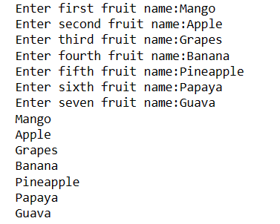

**STRING CONCLUSION** :-

A Python string is a list of characters in order. A character is anything you can type on the keyboard in one Keystore ,like a letter ,a number or a backslash .

Python strings are immutable (cannot change).

Strings in Python are Surrounded by either single quotation marks, and double quotation marks.

**Q.2 Write a Python Program to demonstrate a tuple?**

tup=("RAMSHA","BUSHRA","BAAJI","RAANI","5","8",2,2,1)

Print(type(tup))

Print (tup [0:3])

print (tup [2:5])

print (tup [::])

print (tup [::2])

print (tup [-4:-2])

print (tup [::-1])

print (tup [::-2])

print (tup [:5:1])

print (tup [0:4:2])

**OUTPUT:-**

<class 'tuple'>

('RAMSHA', 'BUSHRA', 'BAAJI')

('BAAJI', 'RAANI', '5')

('RAMSHA', 'BUSHRA', 'BAAJI', 'RAANI', '5', '8', 2, 2, 1)

('RAMSHA', 'BAAJI', '5', 2, 1)

('8', 2)

(1, 2, 2, '8', '5', 'RAANI', 'BAAJI', 'BUSHRA', 'RAMSHA')

(1, 2, '5', 'BAAJI', 'RAMSHA')

('RAMSHA', 'BUSHRA', 'BAAJI', 'RAANI', '5')

('RAMSHA', 'BAAJI')

PS C:\Users\hibba\OneDrive\Documents>

TUPLE CONCLUSION:-

Tuples are used to store multiple items in a single variable.

Tuple is one of 4 built-in data types in python used to store collections of data ,the other 3 are List, set ,and Dictionary ,all with different qualities and usage.

A Tuple is a collection which is ordered and unchangeable .

Tuples are written with round brackets.

**Q.3 Write a Program to demonstrate a list?**

lst=[10,40,30,20,50]

lst .reverse()

print(lst)

lst.sort()

print(lst)

lst.sort(reverse=True)

print(lst)

lst=[10,2,0,50,4]

print(sorted(lst))

print(sorted(lst,reverse=True))

print(list(reversed(lst)))

lst=[10,20,30,3,4,2]

print(lst[::-2])

lst=[12,15,28,39,48,35,23]

lst.append(50)

print(lst)

print(lst.pop())

lst=[12,15,13,28,24,26,20,29]

lst.append(45)

print(lst)

lst.reverse()

print(lst)

lst.sort()

print(lst)

lst. sort(reverse=True)

print(lst)

lst.remove(24)

print(lst)

lst=[5,10,2,3,12,19,26,39]

print(lst.pop())

lst.insert(2,32)

print(lst)

print(lst.count(2))

idx=lst.index(2)

print(idx)

**OUTPUT:-**

[50, 20, 30, 40, 10]

[10, 20, 30, 40, 50]

[50, 40, 30, 20, 10]

[0, 2, 4, 10, 50]

[50, 10, 4, 2, 0]

[4, 50, 0, 2, 10]

[2, 3, 20]

[12, 15, 28, 39, 48, 35, 23, 50]

50

[12, 15, 13, 28, 24, 26, 20, 29, 45]

[45, 29, 20, 26, 24, 28, 13, 15, 12]

[12, 13, 15, 20, 24, 26, 28, 29, 45]

[45, 29, 28, 26, 24, 20, 15, 13, 12]

[45, 29, 28, 26, 20, 15, 13, 12]

39

[5, 10, 32, 2, 3, 12, 19, 26]

1

3

PS C:\Users\hibba\OneDrive\Documents>

**Q.4 Write a program to demonstrate a dictionary?**

dict={}

n=int(input("Enter the number of student:"))

i=1

while i<n:

name=input("Enter student name:")

marks=input("Enter student marks:")

dict[name]=marks

i=i+1

print("Name of student","\t", "Marks")

for x in dict:

print("\t", x,"\t", dict[x])

**OUTPUT:-**

Enter the number of student:3

Enter student name:RAMSHA

Enter student marks:88

Enter student name:HIBBAN

Enter student marks:99

Enter student name:BUSHRA

Enter student marks:98

Name of student Marks

RAMSHA 88

HIBBAN 99

BUSHRA 98

PS C:\Users\hibba\OneDrive\Documents>

**DICTIONARY CONCLUSUION**:-

Dictionaries are used to store data values in key: value pairs.

A dictionary is a collection which is ordered changeable and do not allow duplicates.

Dictionaries are written with curly brackets ,and have keys and values.

**Q**.5 Write a program to demonstrate arithmetic operations?

a=int(input("Enter first number:"))

b=int(input("Enter second number:"))

print("Addition of two number is:",a+b)

print("substraction of two number is:",a-b)

print("Multiplication of two number is:",a*b)

print("Division of two number is:",a/b)

**OUTPUT:-**

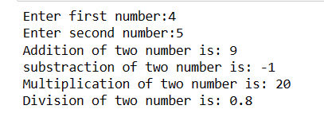

**CONCLUSION AIRTHMETIC OPERATOR:**

Arithmetic operators are used with numeric values to perform common mathematical operations:

There are 7 arithmetic operators in python:

1.Addition

2.substraction

3.Multiplication

4.Division

5.Modulus

6.Exponentiation

7.Floor division

|  |  |  |
| --- | --- | --- |
| Operator | Name | Example |
| + | Addition | a+b |
| - | Subtraction | a-b |
| * | Multiplication | a*b |
| / | Division | a/b |

**Q.6 Write a program to demonstrate comparison operator?**

a=int(input("Enter first number:"))

b=int(input("Enter second number:"))

if(a>b):

print("a is greater than b")

elif(a==b):

print("a is equal to b")

elif(a<b):

print("a is less than b")

else:

print("b is greater then a is")

**OUTPUT:-**

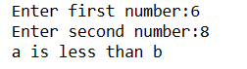

**COMPARISION OPERATOR CONCLUSION:**

If either of the operands is a string value, then a string comparison is used.

Enclose strings in quotes (“string”).

Caution The == operator is a Comparison Operator

|  |  |
| --- | --- |
| **Comparison operator symbol** | **Name** |
| **>** | **Greater than** |
| **<=** | **Less than or equal to** |
| **>=** | **Greater than or equal to** |
| **!~** | **Does not contain** |

**Q.7 Write a program to demonstrate assignment operator?**

a=int(input("Enter first number:"))

b=int(input("Enter second number:"))

a+=b

print(a)

a-=b

print(a)

a*=b

print(a)

a/=b

print(a)

**OUTPUT:-**

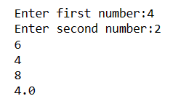

**CONCLUSION OF ASSIGNEMNT OPERATOR:**

The operator is used to assign the value of the right side of the expression

To the left side operand**.**

|  |  |
| --- | --- |
| **Operator** | **Syntax** |
| **+=** | **a=a+b** |
| **-=** | **a=a-b** |
| **\*=** | **a=a*b** |
| **/=** | **a=a/b** |

**Q.8 Write a program to demonstrate bitwise operator**

a = int(input(“Enter a number:”))

b=int(input(“Enter b number:”))

# Print bitwise AND operation

print("a & b =", a & b)

# Print bitwise OR operation

print("a | b =", a | b)

# Print bitwise NOT operation

print("~a =", ~a)

# print bitwise XOR operation

print("a ^ b =", a ^ b)

**OUTPUT**:-

**CNCLUSION OF BITWISE OPERATOR**:

Bitwise operators are used to performing bitwise calculations bitwise calculations on

Integers.

|  |  |  |
| --- | --- | --- |
| Operator | Description | Syntax |
| & | Bitwise AND | X&Y |
| | | Bitwise OR | X|Y |
| ~ | Bitwise NOT | ~X |
| ^ | Bitwise XOR | X^Y |
| >> | Bitwise right shift | X>> |
| << | Bitwise left shift | X<< |

**Q.9 USE REPL and Print the Table of 5 using it?**

num=int(input("Enter a number:"))

print("Multiplication of two number is:",num)

for i in range(1,11):

X=num*i

print(num,"X",i,"=",num*i)

**OUTPUT:-**

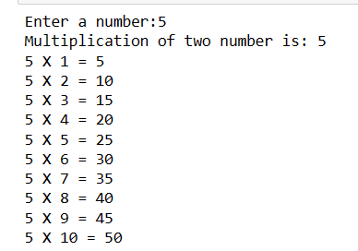

**TABLE CONCLUSION:**

We have used the for loop along with the range() function to iterate 10 times.

The arguments inside the range() function are(1,11).

**Q.10 Write a python program to find average of two numbers entered by the user?**

a=int(input("Enter first number:"))

b=int(input("Enter second number:"))

x=(a+b)/2

print(x)

**OUTPUT:-**

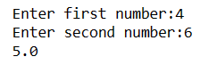

**CONCLUSION AVERAGE OF TWO NUMBERS:**

The Float() Function is used to convert the input to a floating data type .Then ,we find the average of two numbers using the average formula :

**Average =Total sum/Total no. of terms.**

**Q.11 Write a python program to find greatest of four numbers entered by the user?**

num1=int(input("Enter first number:"))

num2=int(input("Enter two number:"))

num3=int(input("Enter three number:"))

num4=int(input("Enter four number:"))

if num1>num2 and num1>num4:

print("1's number is greater")

elif num2>num3:

print("2's number is greater")

elif num3>num4:

print("3's number is greater")

elif num4>num2:

print("4's number is greater")

else:

print("Done")

**OUTPUT:-**

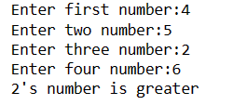

**CONCLUSION OF GREATEST NUMBER:**

Following code should give me highest user input (highest number among the four numbers)

**Q.12 Write a python program to calculate the square of two numbers entered by the user?**

a=int(input("Enter first number:"))

b=int(input("Entre second number:"))

x=a**b;

print("square of a number:",x)

**OUTPUT:-**

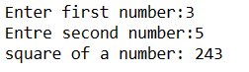

**Q.13 Write a python program to fill in a letter template with a name and date?**

name=input("name:")

date=input("date:")

formatted_letter="\n\tName: “+name+”\n\tDate:28/10/2022\n"

print(formatted_letter)

**OUTPUT:-**

name:RAMSHA

date:04/01/2023

Name: RAMSHA

Date:28/10/2022

PS C:\Users\hibba\OneDrive\Documents>

**Q.14 Write a python program to detect double space in a string?**

s=input("Enter a string:")

print("The string is:",s)

print("Detect double space at index:",s.find(' '))

**OUTPUT:-**

Enter a string:HIBBANUR RAHMAN

The string is: HIBBANUR RAHMAN

Detect double space at index: -1

PS C:\Users\hibba\OneDrive\Documents>

CONCULUSION OF DOUBLE SPACE DETECT:

**-**Checking Double space detect in python we can use s.find(substring).

**Q.15 Write a python program to accept marks of six students and display them in a sorted manner?**

marks = []

for i in range(6):

marks.append(int(input("Enter marks of student " + str(i+1) + ": ")))

marks.sort()

print("Sorted marks: ")

for i in range(6):

print(marks[i])

**OUTPUT:-**

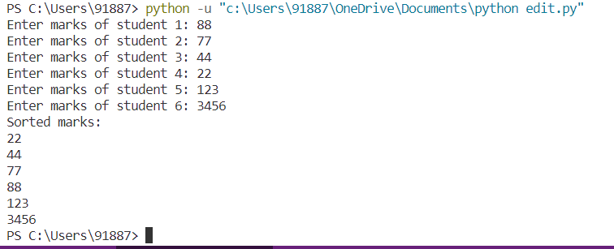

**CONCLUSION OF SORTED LIST :-**

python also provides built in function to sort. The sort function can be used to sort the list in both ascending and descending order. To sort the list in ascending order. Its time complexity is O(NlogN).

Q.16 **Write a python program to count the number of zeroes in the given tuple such as a=(7,0,8,0,0,9)?**

tuple=(7,0,8,0,0,9)

print(tuple.count(0))

**OUTPUT:-**



**Q.17 Create a list and perform the following methods**

**1)insert() 2) remove 3)append() 4)len() 5)pop() 6)clear()**

list=["RAMSHA","HIBBAN","BUSHRA","RAANI","BAAJI",9,10]

print(list)

list.insert(3,"RAANI")

print(list)

list.remove("BAAJI")

print(list)

list.append("Farhan")

print(list)

s=["HIBBAN",6,"RAMSHA",9,"BUSHRA"]

print(len(s))

print(s.pop())

print(s.clear())

**OUTPUT:-**

['RAMSHA', 'HIBBAN', 'BUSHRA', 'RAANI', 'BAAJI', 9, 10]

['RAMSHA', 'HIBBAN', 'BUSHRA', 'RAANI', 'RAANI', 'BAAJI', 9, 10]

['RAMSHA', 'HIBBAN', 'BUSHRA', 'RAANI', 'RAANI', 9, 10]

['RAMSHA', 'HIBBAN', 'BUSHRA', 'RAANI', 'RAANI', 9, 10, 'Farhan']

5

BUSHRA

None

PS C:\Users\hibba\OneDrive\Documents>

**CONCULUSION OF LIST:-MANIPULATING OF LIST**

1.list.insert() we insert element at specific position

2.list.remove() we remove any element

3.list.append() we append any element

4.list.len() we check length of string

5.list.pop() we remove LIFO and FILO element

6.list.clear() clear all elements

**Q.18 Create a dictionary and apply the following methods**

**1)print the dictionary items 2)access items 3)use get 4)change values 5)use len()?**

d={"RAMSHA PARVEEN":"RAANI","BUSHRA PARVEEN":"BAAJI","Farhan":"BHAIJAN"}

print(d)

print(d.items())

print(d.get("RAMSHA PARVEEN"))

print(len(d))

**OUTPUT:-**

{'RAMSHA PARVEEN': 'RAANI', 'BUSHRA PARVEEN': 'BAA

JI', 'Farhan': 'BHAIJAN'}

dict_items([('RAMSHA PARVEEN', 'RAANI'), ('BUSHRA

PARVEEN', 'BAAJI'), ('Farhan', 'BHAIJAN')])

RAANI

3

PS C:\Users\hibba\OneDrive\Documents>

**CONCLUSION OF DICTIONARY:-**

1.d.items() access the all dictionary items

2.d.get() acess only values of dictionary

3.len() len is overall dictionary length

4.change() change function used for key replace

**Q.19 Write a tuple and perform the following methods**

**1)Add items 2)len() 3)check for item in tuple 4)Access items**

tuple=('H','I','B','B','A','N')

print(tuple)

tuple=tuple+('R','A','H','M','A','N')

print(tuple)

print(len(tuple))

print('M'in tuple)

**OUTPUT:-**

('H', 'I', 'B', 'B', 'A', 'N')

('H', 'I', 'B', 'B', 'A', 'N', 'R', 'A', 'H', 'M',

'A', 'N')

12

True

PS C:\Users\hibba\OneDrive\Documents>

**Q.20 Write a python program to find factorial of a given number using function?**

import math

def fact(n):

return(math.factorial(n))

num=int(input("Enter a number:"))

f=fact(num)

print("factorial of",num,"is",f)

**OUTPUT:**-

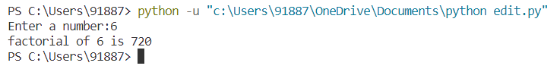

**CONCULUSION OF FACTORIAL**:

Factorial is a non-negative integer. It is the product of all positive integers less than or equal to that number you ask for factorial.

f=f*n

**Q.21 Write a python program for filter() to filter only even numbers from a given list?**

list=[3,5,6,4,2,8,6,5,12]

for i in list:

if i%2==0:

print(i,end=’’)

**OUTPUT:-**

6,4,2,8,6,12

PS C:\Users\hibba\OneDrive\Documents>

**CONCLUSION:-**

We are used a condition for even number condition is i%2==0 this condition is true then return even number neither odd number**.**

**Q.22 Write a python program for map() function to double all the items in the list?**

def double(x):

return x*2

print(list(map(double, [1,2,3,4])))

**OUTPUT:-**



**CONCLUSION:-**

The map() function executes a specified function for each item in an iterable. The item is sent to the function as a parameter.

**Q.23 Write a python program to find sum of the numbers for the elements of the list by using reduce?**

from functools import reduce

def sum(x,y):

return x+y

lst = [1,2,3,4,5,6,7,8,9,10]

print(reduce(sum,lst))

**OUTPUT:-**

5

PS C:\Users\hibba\OneDrive\Documents>

**Q.24 Write a python program to write the content “hi python programming “ for existing file?**

f = open("test.txt", "w")

f.write("hi python programming")

f.close()

**OUTPUT:-**

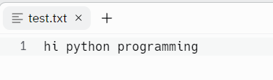

**Q.25 Write a python program to display a particular month of a year using calendar module?**

import calendar

year=int(input("Enter year:"))

month=int(input("Enter month:"))

print(calendar.month(year,month))

**OUTPUT:-**

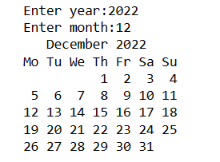

**Q.26 Write a python program which accepts the radius of a circle from user and computes the area (user math module)**

from math import pi

r=float(input("Enter radius:"))

print("The area of a circle and radius "+str(r)+" is:"+str(pi * r**2))

**OUTPUT:-**

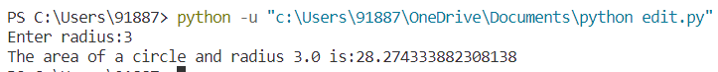

**CONCLUSION:**

We are used of area of circle formula a=pi*r**2

**Q.27 Write a python program to read 3 subject marks and display pass or failed using class and object?**

class Student:

def __init__(self,name,marks):

self.name=name

self.marks=marks

def display(self):

print("Name:",self.name)

print("Marks:",self.marks)

def grade(self):

if self.marks>=60:

print("Pass")

else:

print("Fail")

n=int(input("Enter the number of students:"))

for i in range(n):

name=input("Enter the name of the student:")

marks=int(input("Enter the marks of the student:"))

s=Student(name,marks)

s.display()

s.grade()

**OUTPUT:-**

Enter the number of students:3

Enter the name of the student:HIBBANUR RAHMAN

Enter the marks of the student:88

Name: HIBBANUR RAHMAN

Marks: 88

Enter the name of the student:RAMSHA PARVEEN

Enter the marks of the student:89

Name: RAMSHA PARVEEN

Marks: 89

Enter the name of the student:BUSHRA PARVEEN

Enter the marks of the student:90

Name: BUSHRA PARVEEN

Marks: 90

Pass

PS C:\Users\hibba\OneDrive\Documents>

**Q.28 Using a numpy module create an array and check the following:**

**1.Type of array 2.Axes array 3.shape of array 4.Type of elements in array?**

import numpy as np

arr = np.array( [[ 1, 2, 3],

[ 4, 2, 5]])

print("Array is of type: ", type(arr))

print("Shape of array: ", arr.shape)

print("Size of array: ", arr.size)

print("Array stores elements of type: ", arr.dtype)

print("Axes of array:",arr[np.array([0,1])])

**OUTPUT:-**

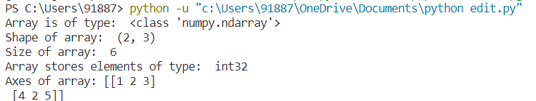

**Q.29 You are given a string s. You need to reverse the string**.

**Example 1:**

**Input:**

s = Geeks

**Output:** skeeG

def reverseWord(s):

s=s[::-1]

return s

**OUTPUT:-**

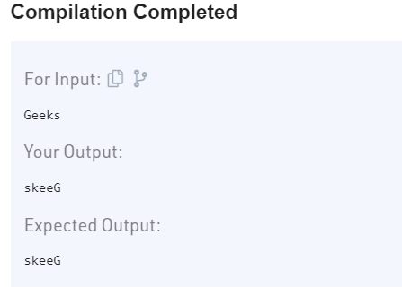

**Q.30 Your task is to implement the function strstr. The function takes two strings as arguments (s,x) and  locates the occurrence of the string x in the string s. The function returns and integer denoting the first occurrence of the string x in s (0 based indexing).**

**Example 1:**

**Input:**

s = GeeksForGeeks, x = Fr

**Output:** -1

**Explanation:** Fr is not present in the

string GeeksForGeeks as substring.

def strstr(s,x):

return(s.find(x))

**OUTPUT:-**

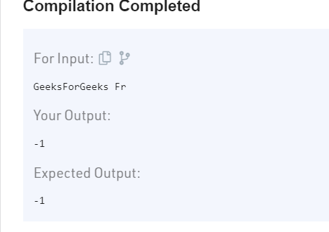

Q.31 **You will be given two numbers a and b. Your task is to print 1 if a < b, print 2 if a > b and print 3 if a = b.**

**Example 1:**

**Input:**

a = 1234

b = 12345

**Output:** 1

**Explanation:** a < b so answer is 1.

class Solution:

def check(self, a,b):

if a<b:

return 1

elif a>b:

return 2

else:

return 3

**OUTPUT:-**

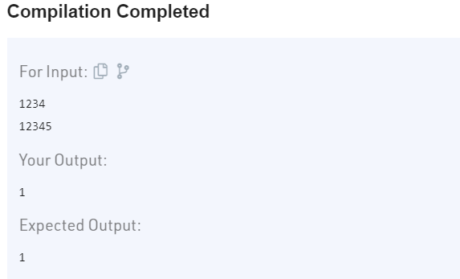

**Q.32 Given an integer array arr of size n, you need to sum the elements of arr.**

**Example 1:**

**Input:**

n = 3

arr[] = {3 2 1}

**Output:** 6

def sumElement(arr,n):

return sum(arr[0:n])

**OUTPUT:-**

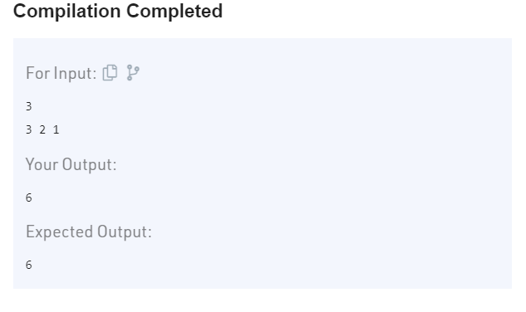

Q.33 **Given an integer array and another integer element. The task is to find if the given element is present in array or not.**

**Example 1:**

**Input:**

n = 4

arr[] = {1,2,3,4}

x = 3

**Output:** 2

**Explanation:** There is one test case

with array as {1, 2, 3 4} and element

to be searched as 3.  Since 3 is

present at index 2, output is 2.

class Solution:

#Complete the below function

def search(self,arr, N, X):

for i in range(0,N):

if X==arr[i]:

return i

return -1

**OUTPUT:-**

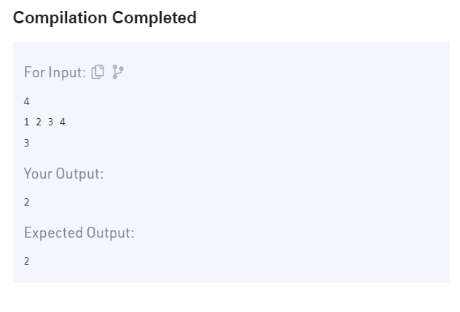

**Q.34** Given an array **A[]**of size **n**. The task is to find the largest element in it.

**Example 1:**

**Input:**

n = 5

A[] = {1, 8, 7, 56, 90}

**Output:**

90

**Explanation:**

The largest element of given array is 90.

def largest( arr, n):

max=arr[0]

for i in range(1,n):

if arr[i] > max:

max = arr[i]

return(max)

**OUTPUT:**

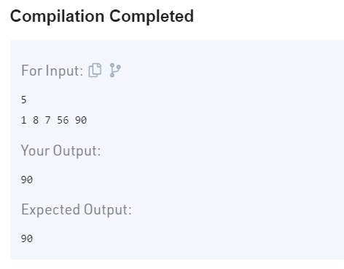

**Q.35 Given two numbers as strings s1 and s2. Calculate their Product**. **Note:** The numbers can be negative andYou are not allowed to use any built-in function or convert the strings to integers.  
**Example 1:**

**Input:**

**s1 =** "33"

**s2 =** "2"

**Output:**

66

Class Solution:

def multiplyStrings(self,s1,s2):

s=int(s1)*int(s2)

return(s)

**OUTPUT:-**

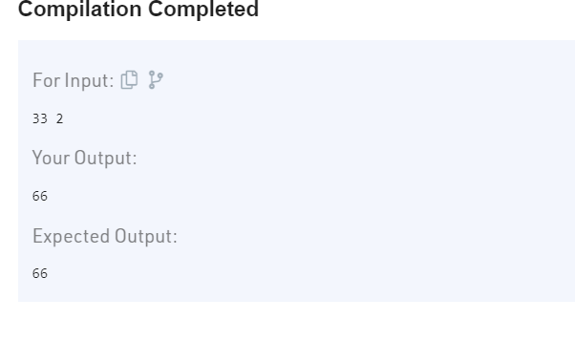

**Q.**36 **Given a string S. The task is to convert characters of string to lowercase.**

**Example 1:**

**Input: S** = "ABCddE"

**Output:** "abcdde"

**Explanation:** A, B, C and E are converted to

a, b, c and E thus all uppercase characters

of the string converted to lowercase letter.

class Solution:

def toLower (ob, S):

return(S.lower())

**OUTPUT:-**

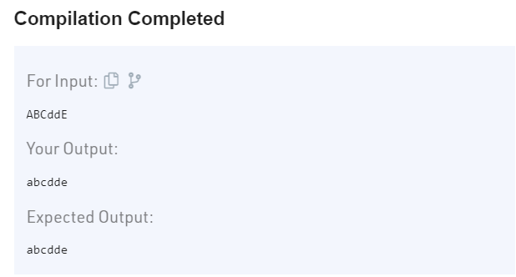

**Q.37** Given a string str, convert the first letter of each word in the string to uppercase.

**Example 1:**

**Input:**

str = "i love programming"

**Output:** "I Love Programming"

**Explanation:**

'I', 'L', 'P' are the first letters of

the three words.

class Solution:

def transform(self, s):

return (s.title())

**OUTPUT:-**

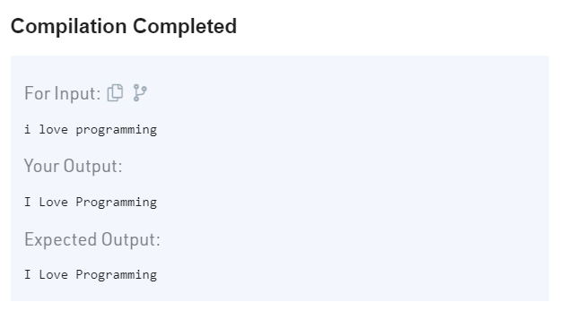

**Q.38 Python program to check whether a number is Prime or not?**

num = 11

if num > 1:

for i in range(2, int(num/2)+1):

if (num % i) == 0:

print(num, "is not a prime number")

break

else:

print(num, "is a prime number")

else:

print(num, "is not a prime number")

**OUTPUT:-**

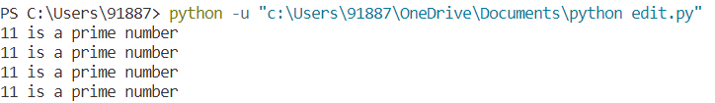

**Q.39 Reversing a List in Python?**

lst = [10, 11, 12, 13, 14, 15]

lst.reverse()

print("Using reverse() ", lst)

print("Using reversed() ", list(reversed(lst)))

**OUTPUT:-**



**Q.40 Python program to print odd numbers in a List?**

list1 = [10, 21, 4, 45, 66, 93]

for num in list1:

if num % 2 != 0:

print(num, end=" ")

**OUTPUT:-**



**Q.41 Assigning Subsequent Rows to Matrix first row elements?**

test_list = [[5, 8, 9], [2, 0, 9], [5, 4, 2], [2, 3, 9]]

print("The original list : " + str(test_list))

res = {test_list[0][ele] : test_list[ele + 1] for ele in range(len(test_list) - 1)}

print("The Assigned Matrix : " + str(res))

**OUTPUT:-**

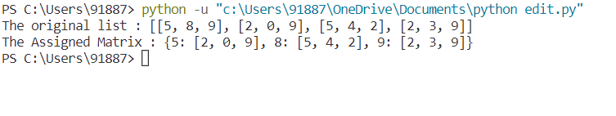

Q.42 **Sum of tuple elements?**

def summation(test_tup):

test = list(test_tup)

count = 0

for i in test:

count += i

return count

test_tup = (5, 20, 3, 7, 6, 8)

print(summation(test_tup))

**OUTPUT:-**

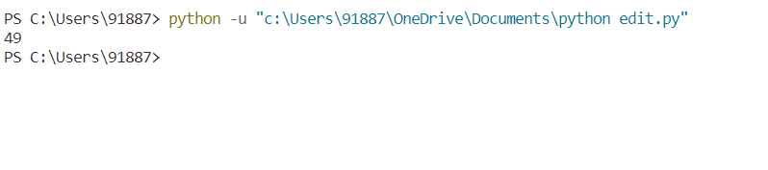

Q.43 Make a Python script that checks if a given number is prime.

n = 37

**if** n == 2:

**print**("2 is a prime number")

**if** n != 1:

**for** i **in** range(2, n):

**if** n % i == 0:

**print**("The given number is a composite number")

**break**

**if** i == n-1:

**print**("The given number is a prime number")

**else**:

**print**("1 is not a prime number")

**OUTPUT:-**

The given number is a prime number

PS C:\Users\hibba\OneDrive\Documents>

**Q.44 Given two numbers as strings s1 and s2. Calculate their Product.**  
**Note:** The numbers can be negative andYou are not allowed to use any built-in function or convert the strings to integers.

**Example 1:**

**Input:**

**s1 =** "33"

**s2 =** "2"

**Output:**

66

class Solution:

def multiplyStrings(self,s1,s2):

s=int(s1)*int(s2)

return(s)

**OUTPUT:-**

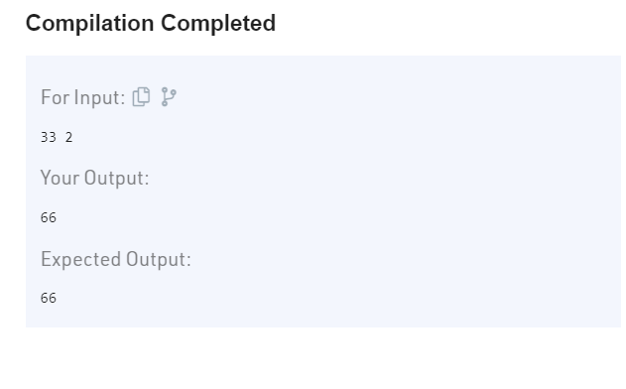

**Q.45 Given a String S, reverse the string without reversing its individual words. Words are separated by dots.**

**Example 1:**

**Input:**

S = i.like.this.program.very.much

**Output:** much.very.program.this.like.i

**Explanation:** After reversing the whole

string(not individual words), the input

string becomes

much.very.program.this.like.i

class Solution:

#Function to reverse words in a given string.

def reverseWords(self,S):

l=S.split(".")

l1=[]

i=len(l)-1

while i>=0:

l1.append(l[i][::1])

i=i-1

output=".".join(l1)

return(output)

**OUTPUT:-**

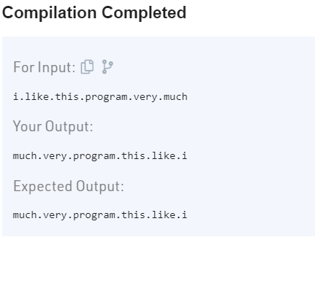

**Q.46** Given a String. Reverse each word in it where the words are separated by dots.

**Example 1:**

**Input:**

S = "i.like.this.program.very.much"

**Output:**

i.ekil.siht.margorp.yrev.hcum

**Explanation**:

The words are reversed as

follows:"i" -> "i","like"->"ekil",

"this"->"siht","program" -> "margorp",

"very" -> "yrev","much" -> "hcum".

class Solution:

def reverseWords(self, s):

l=s.split(".")

l1=[]

for word in l:

l1.append(word[::-1])

reversewords=".".join(l1)

return(reversewords)

**OUTPUT:-**

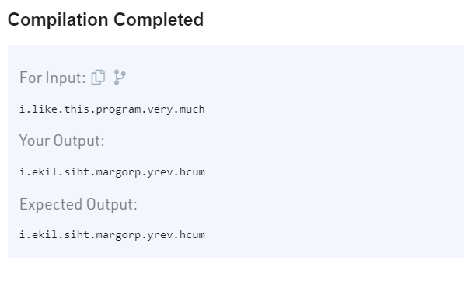

**Q.47 Given an integer N, find its factorial**.  
  
**Example 1:**

**Input:** N = 5

**Output:** 120

## **Explanation** : 5! = 1*2*3*4*5 = 120

class Solution:

def factorial(self, N):

f=1

for i in range(1,(N+1)):

f=f*i

return str(f)

**OUTPUT:-**

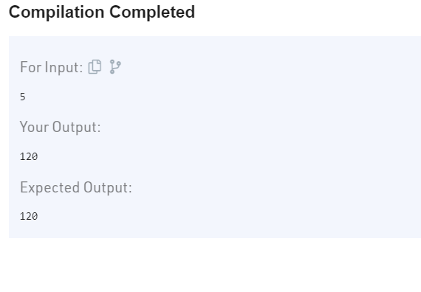

## **Q.48**  **Python program to convert the temperature in degree centigrade to Fahrenheit?**

celsius=int(input("Enter the temperature in celcius:"))

f=(celsius*1.8)+32

print("Temperature in farenheit is:",f)

**OUTPUT:-**

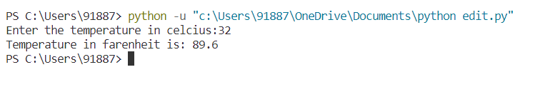

Q.49 Python program to find the area of a triangle whose sides are given?

import math

a = float(input("Enter the length of side a: "))

b = float(input("Enter the length of side b: "))

c = float(input("Enter the length of side c: "))

s = (a+b+c)/2

area = math.sqrt(s*(s-a)*(s-b)*(s-c))

print(" Area of the triangle is: ", area)

**OUTPUT:-**

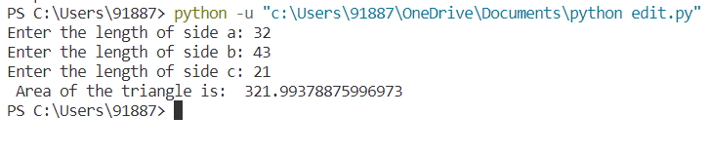

Q.50 Python program to find the circumference and area of a circle with a given radius?

import math

r = float(input("Input the radius of the circle: "))

c = 2 * math.pi * r

area = math.pi * r * r

print("The circumference of the circle is: ", c)

print("The area of the circle is: ", area)

**OUTPUT:-**

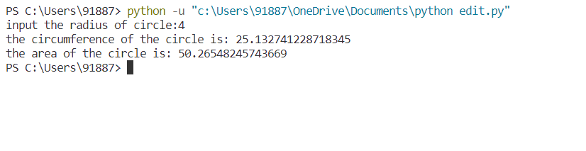

Q.51  Python program to check whether the given integer is a multiple of 5?

number = int(input("Enter an integer: "))

if(number%5==0):

print(number, "is a multile of 5")

else:

print(number, "is not a multiple of 5")

**OUTPUT:-**

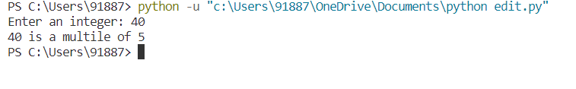

Q.52 Python program to check whether the given integer is a multiple of both 5 and 7?

number = int(input("Enter an integer: "))

if((number%5==0)and(number%7==0)):

print(number, "is a multiple of both 5 and 7")

else:

print(number, "is not a multiple of both 5 and 7")

**OUTPUT:-**



Q.53 Python program to find the average of 10 numbers using while loop?

count = 0

sum = 0.0

while(count<10):

number = float(input("Enter a real number: "))

count=count+1

sum = sum+number

avg = sum/10;

print("Average is :",avg)

**OUTPUT:-**

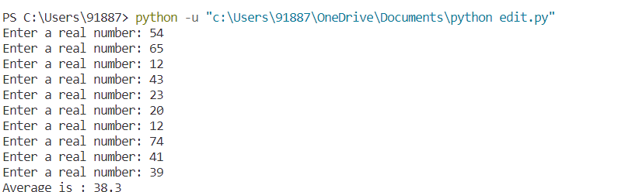

Q.54 Python program to display the given integer in reverse manner?

number = int(input("Enter a positive integer: "))

rev = 0

while(number!=0):

digit = number%10

rev = (rev*10)+digit

number = number//10

print(rev)

**OUTPUT:-**



Q.55 Python program to find the sum of the digits of an integer using while loop?

sum = 0

number = int(input("Enter an integer: "))

while(number!=0):

digit = number%10

sum = sum+digit

number = number//10

print("Sum of digits is: ", sum)

**OUTPUT:**



Q.56 Python program to display all the multiples of 3 within the range 10 to 50?

**for i in range(10,50):**

**if (i%3==0):**

**print(i)**

**OUTPUT:-**

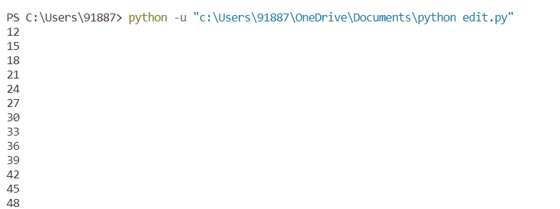

Q.57 find Pattern1 question?

for i in range(1,6):

for k in range(1,6-i):

print(" ",end="")

for j in range(1,i+1):

print("*",end="")

print("\n")

**OUTPUT:**

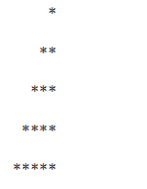

**Q.58 Find pattern2 question?**

for i in range(1,6):

for k in range(1,6-i):

print(" ",end="")

for j in range(1,i+1):

print(" * ",end="")

print("\n")

**OUTPUT:-**

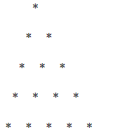

**Q.59 Find pattern3 question?**

for i in range(1,6):

for j in range(1,6-i+1):

print("*",end="")

print("\n")

**OUTPUT:-**

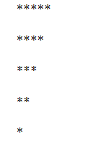

**Q.60 Find pattern4 question?**

for i in range(1,6):

for j in range(1,i+1):

print("*",end="")

print("\n")

**OUTPUT:-**

